

Iqueue Project

Testing Document

Software Engineering for Automation (2022-2023)



Summary

1. White Box Testing 2

1.1 Booking view 3

1.2 Shop view 12

2. Black Box Testing 16

**2.1** Test set: **Account Registration** 16

2.2 Test set: **Shop registration** 19

2.3 Test set: **Booking and QR reading** 21

2.4 Test set: **Queue** 24

2.5 Test set: **Product** 29

2.6 Test set: **Advertisement** 32

3. Conclusions 34

DA CAMBIARE FOTO CON QUELLE DEL TEMPLATE NUOVO

The following documentation helps to explain the different testing benchmarks applied to the Iqueue software. For each of the most important components of the software, some test sets are developed in order to guarantee their robustness to possible wrong inputs from the users and to assure that the outputs of the system are anyway correct. With testing, we have followed a continuous process of validation and verification, that allowed us to improve our code robustness and compliance with specifications.

We want to remark on two important traits of testing: the independence of its validity from the chosen programming language and the fact that it cannot guarantee the absence of errors but permits detecting their presence. As Dijkstra stated, “*Program testing can be used to show the presence of bugs, but never to show their absence*”.

Good testing should behold the following features:

1. Help isolate errors.
2. Be repeatable.
3. Be accurate.

# White Box Testing

We choose to test the code related to the booking view and the shop view. To ease the readability of the code, we chose to add proper comments. In addition, the relative application pages will be reported.

Test sets employed in the white-box testing will be identified based on the following criteria:

* Statement Coverage
* Edge Coverage
* Condition Coverage
* Path Coverage

Then, in each test for every coverage criteria, a coverage-based test evaluation will be performed to assess to test validity:

$$Percentage of coverage= \frac{Number of items covered}{Total number of items} ×100$$

# Booking view

We choose to test the code related to the booking view, thus the code that allows a customer to book a slot of a certain shop, since this is one of the most important features of our application. In addition, the relative application pages will be reported.

**Software tested**

**Iqueue – booking view**

**Version**

Latest

**Goal**

To test if significant parts of the program structure are inadequate.

Code

def Booking_view(request, selected_category):

    #Loading of the Django forms into variables

    Shop_and_day_form = forms.Shop_and_day_selectionForm()

    TimeSlot_form = forms.TimeSlot_selectionForm()

    #Filtering of the shops based on the category that the customer has selected in the previous view

    shops = Shop.objects.filter(category=selected_category)

    #Identification of the actual queue and the rating of every shop of the selected category to populate the map with them

    queues = []

    reviews = []

    for shop in shops:

        timeslot1 = TimeSlot.objects.filter(shop=shop)

        num_av_slots, _, _ = shop.checkQueue(timeslot1)

        shop.queue = num_av_slots + shop.queue_no_app

        shop.save()

        queues.append(shop.queue)

        reviews.append(shop.rating)

    #Identification of the shop addresses and names to populate the map properly

    addresses = [shop.address for shop in shops]

    names = [shop.name for shop in shops]

    #Condition that verifies if form is sent

    if request.method == 'POST':

        #Condition that verifies if the first form is sent, thus the one of the shop selection to inspect its time slots

        if 'btnform1' in request.POST:

            # Recover the information of the selected shop and date

            shop_ids = request.POST.get('shop_ids')

            date = request.POST.get('date')

# Checking on the validity of the date

            if  date < date.today():

                return render(request, 'ErrorPastBooking.html')

            #Finding out the associeted objects

            shop_sel = Shop.objects.get(ids=shop_ids)

            timeslots_shop_sel = TimeSlot.objects.filter(shop=shop, date=date, available=True)

            #Returning the webpage where now the available slots (if there are) are showed

context2={'shops': Shop.objects.filter(category=selected_category),

            'timeslots': timeslots,

            'Shop_and_day_form': Shop_and_day_form, 'TimeSlot_form': TimeSlot_form,

'addresses': addresses, 'names': names, 'queues': queues, 'reviews': reviews}

            return render(request, 'booking.html',context=context2)

        #Condition that verifies if the second form is sent, thus the one of the time-slot selection to make the reservations if possible

        if 'btnform2' in request.POST and 'selected_slot' in request.POST:

            #Recovering the information of the actual customer of its selected time slot

            idc = request.session.get('idc', '')

            selected_timeslot_id = request.POST.get('selected_slot')

            #Identification of the associated timeslot object, its slots and its associeted shop

            timeslot = get_object_or_404(TimeSlot, id=selected_timeslot_id)

            slot = Slot.objects.filter(TimeSlot=timeslot, available=True).first()

            shop = timeslot.shop

            #Making the reservation for the customer: association of the slot to him and the slot is now unavailable

            slot.available = False

            slot.idc = idc

            slot.save()

            #Checking if the availability of the time slot: if all of the slots are unavailable, the it is also their timeslot

            if not Slot.objects.filter(available=True, TimeSlot=timeslot).exists():

                timeslot.available = False

                timeslot.save()

            #Creation of the QR to keep track of the reservation and rendering of its html webpage

… Code …

            context3={'qr_code_img': qr_code_img_str,

'shop': Shop.objects.filter(category=selected_category).values(),

                      'QR': qr, 'addresses': addresses,

                      'Shop_and_day_form': Shop_and_day_form,

                       'TimeSlot_form': TimeSlot_form}

            return render(request, 'qr.html',context=context3)

    Context1 = {

        'shops': Shop.objects.filter(category=selected_category),

        'Shop_and_day_form': Shop_and_day_form,

        'TimeSlot_form': TimeSlot_form,

        'addresses': addresses,

        'names': names,

    }

    return render(request, 'booking.html', context=context1)

Control Flow graph

For simplicity, the rows associated with the setting of the context will not be reported in the control flow graph and the buttons realized in the html template that allows changing the webpage will not be considered; The for loops associated with the compilation of the addresses and names lists will be reported as statement blocks and not conditional ones since they are just employed to compile the two lists.

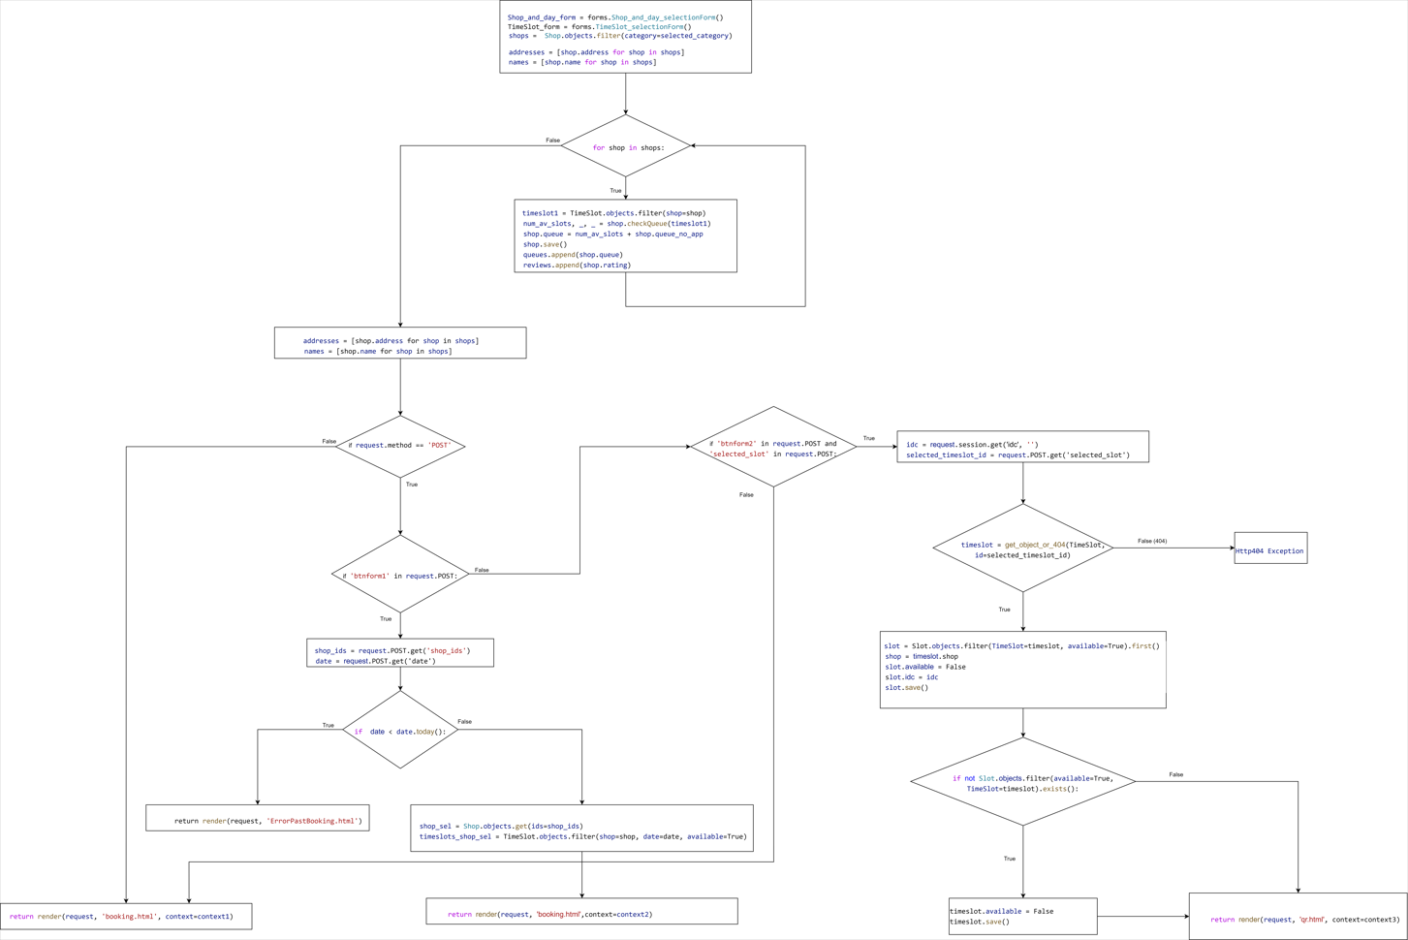Figure 1: Control Flow graph Booking view

(A better image is in the folder White_box-Control flow graph)

Here to identify what btnform1 and btnform2 are, the screenshots of the application are reported. In order to send the form with btnform1 the customer must have selected a date from the aside selection field. The webpage has been realized so that the btnform2 can be pressed only after that the btnform1 has been pressed at least once and the btnform1 and btnform2 cannot be sent together.

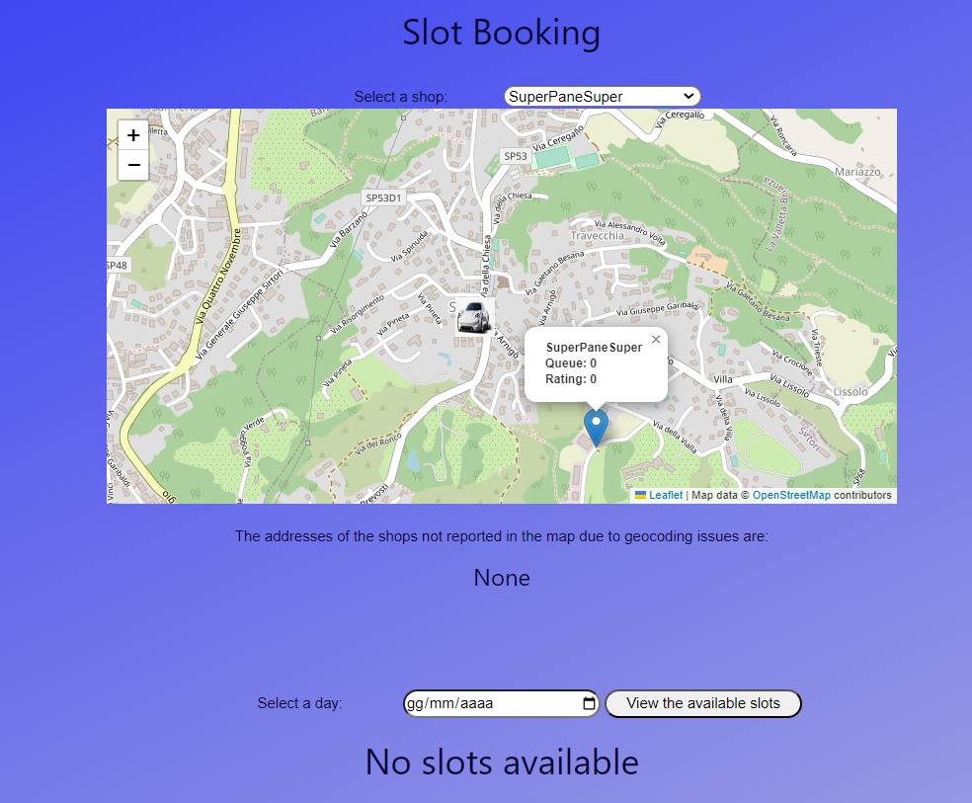

btnform1

Figure 2: Screenshoot 1 (booking)

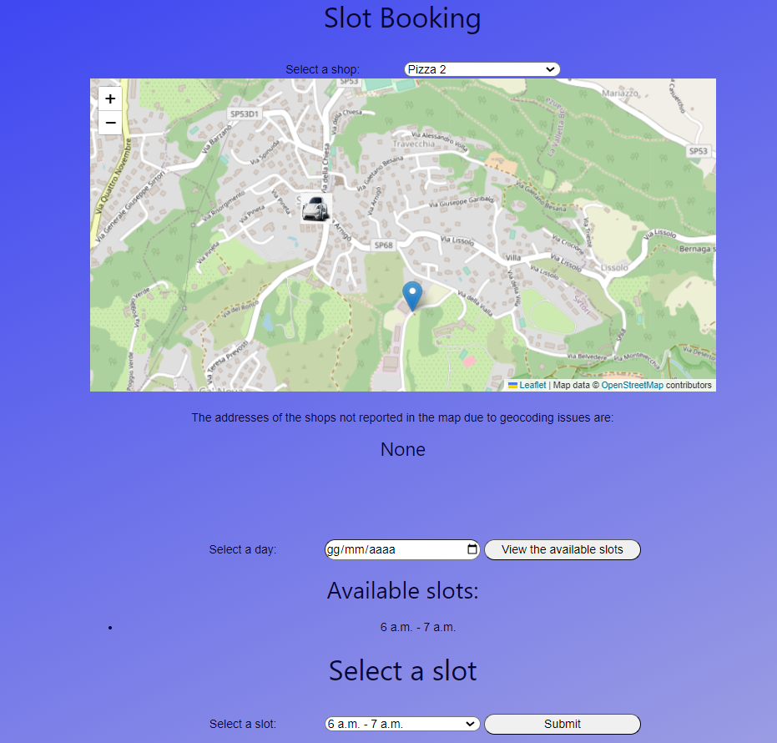

btnform2

Figure 3: Screenshoot 2 (booking)

If no shops are provided by the initial query, the webpage appears as follows thanks to the code in the html template. In this case, btnform1 and btnform2 cannot be pressed.

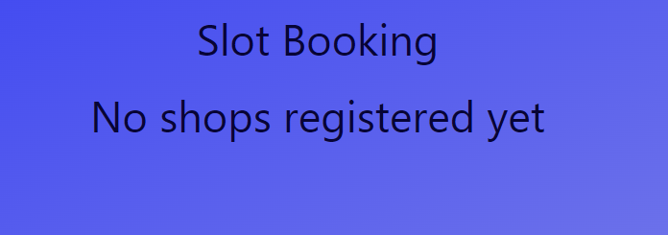

Figure 4: No shops registeres (booking)

Before dealing with the different control flow coverage criteria, a description of the inputs of the test cases is provided:

* selected_category: it is the day the customer wants to make a reservation.
* date: it is the day the costumer wants to make its reservation.
* shop_ids: it is the ID code associated with the shop selected by the customer. It is described by a string of 36 characters.
* btnform1: button that sends the first form (see above). True means that the button has been pressed, false that it has not been pressed.
* btnform2: button that sends the second form (see above). True means that the button has been pressed, false that it has not been pressed.
* selected_slot: id assigned by Django to the TimeSlot object to record it in the database.

Since the webpage and so the booking view will be reloaded when we reach the return render(request,'booking.html', context=… ) statement, we consider ending the test case when we reach it.

As date.today()will be considered the 14.06.2023.

Statement Coverage

Test set:

{ < selected_category = Bakery, btnform1 = FALSE, date = None, shop_ids = a7b8da0f-b6ba-4f69-9b4e-119181849180, btnform2 = FALSE, selected_slot = None>,

< selected_category = Bakery, btnform1 = TRUE, date = 17.05.2024, shop_ids = a7b8da0f-b6ba-4f69-9b4e-119181849180, btnform2 = FALSE, selected_slot = None>,

< selected_category = Bakery, btnform1 = TRUE, date = 17.05.2023, shop_ids = a7b8da0f-b6ba-4f69-9b4e-119181849180, btnform2 = FALSE, selected_slot = None>,

< selected_category = Bakery, btnform1 = FALSE, date = None, shop_ids = None, btnform2 = TRUE, selected_slot = 268954>}

In this case are covered all the statements apart from the situation where timeslot = get_object_or_404(TimeSlot, id=selected_timeslot_id) returns the HTTP 404 exception. This situation cannot be reached since the selectable timeslot is always registered in the Django database thanks to the webpage settings.

Considering the percentage of coverage:

$${\left.Percentage of coverage\right|}_{statement}= \frac{Number of statements covered}{Total number of statements} ×100$$

We have in this case:

Number of statements covered = 54

Total number of statements = 55 (including the HTTP 404 exception)

Percentage of coverage = 98%

Edge Coverage

Test set:

{ < selected_category = Bakery, btnform1 = FALSE, date = None, shop_ids = a7b8da0f-b6ba-4f69-9b4e-119181849180, btnform2 = FALSE, selected_slot = None>,

< selected_category = Bakery, btnform1 = TRUE, date = 17.05.2024, shop_ids = a7b8da0f-b6ba-4f69-9b4e-119181849180, btnform2 = FALSE, selected_slot = None>,

< selected_category = Bakery, btnform1 = TRUE, date = 17.05.2023, shop_ids = a7b8da0f-b6ba-4f69-9b4e-119181849180, btnform2 = FALSE, selected_slot = None>,

< selected_category = Bakery, btnform1 = FALSE, date = None, shop_ids = None, btnform2 = TRUE, selected_slot = 268954>,

< selected_category = Bakery, btnform1 = FALSE, date = None, shop_ids = None, btnform2 = TRUE, selected_slot = 268975>}

In this case, all the edges are covered apart from these two:

1. The one associated with the HTTP 404 exception of timeslot = get_object_or_404(TimeSlot, id=selected_timeslot_id). As said previously, this situation cannot be reached since the selectable timeslot is always registered in the Django database thanks to the webpage settings.
2. The one associated with the false condition of if 'btnform2' in request.POST and 'selected_slot' in request.POST because to reach this condition, the btnform2 must be pressed (so the first statement is always true if we reach this condition) and when we press this button a selected_slot is always selected due to the webpage settings.

Considering the percentage of coverage:

$${\left.Percentage of coverage\right|}_{edges} = \frac{Number of edges covered}{Total number of edges} ×100$$

We have in this case:

Number of edges covered = 20

Total number of edges = 22 (including the HTTP 404 exception)

Percentage of coverage = 91%

Condition Coverage

Test set:

{< selected_category = Others, btnform1 = FALSE, date = None, shop_ids = a7b8da0f-b6ba-4f69-9b4e-119181849180, btnform2 = FALSE, selected_slot = None>,

< selected_category = Bakery, btnform1 = FALSE, date = None, shop_ids = a7b8da0f-b6ba-4f69-9b4e-119181849180, btnform2 = FALSE, selected_slot = None>,

< selected_category = Bakery, btnform1 = TRUE, date = 17.05.2024, shop_ids = a7b8da0f-b6ba-4f69-9b4e-119181849180, btnform2 = FALSE, selected_slot = None>,

< selected_category = Bakery, btnform1 = TRUE, date = 17.05.2023, shop_ids = a7b8da0f-b6ba-4f69-9b4e-119181849180, btnform2 = FALSE, selected_slot = None>,

< selected_category = Bakery, btnform1 = FALSE, date = None, shop_ids = None, btnform2 = TRUE, selected_slot = 268954>,

< selected_category = Bakery, btnform1 = FALSE, date = None, shop_ids = None, btnform2 = TRUE, selected_slot = 268975>}

In the first test case, we have considered a situation where there are no shops of category others.

In this case, all conditions are covered apart from these:

1. The one associated with the HTTP 404 exception of timeslot = get_object_or_404(TimeSlot, id=selected_timeslot_id).
2. The two associated with the false condition of if 'btnform2' in request.POST and 'selected_slot' in request.POST because to reach this condition, the btnform2 must be pressed (so the first statement is always true if we reach this condition): due to this, this condition will be never false. In addition, when we press this button a selected_slot is always selected due to the webpage settings and so we are never in a situation where the first statement is true and the second is false.

Considering the percentage of coverage:

$${\left.Percentage of coverage\right|}_{condition}= \frac{Number of Conditions covered}{Total number of conditions} ×100$$

We have in this case:

Number of conditions covered = 10

Total number of conditions = 13 (including the HTTP 404 exception)

Percentage of coverage = 77%

Path Coverage

Test set:

{< selected_category = Others, btnform1 = FALSE, date = None, shop_ids = a7b8da0f-b6ba-4f69-9b4e-119181849180, btnform2 = FALSE, selected_slot = None>,

< selected_category = Bakery, btnform1 = FALSE, date = None, shop_ids = a7b8da0f-b6ba-4f69-9b4e-119181849180, btnform2 = FALSE, selected_slot = None>,

< selected_category = Bakery, btnform1 = TRUE, date = 17.05.2024, shop_ids = a7b8da0f-b6ba-4f69-9b4e-119181849180, btnform2 = FALSE, selected_slot = None>,

< selected_category = Bakery, btnform1 = TRUE, date = 17.05.2023, shop_ids = a7b8da0f-b6ba-4f69-9b4e-119181849180, btnform2 = FALSE, selected_slot = None>,

< selected_category = Bakery, btnform1 = FALSE, date = None, shop_ids = None, btnform2 = TRUE, selected_slot = 268954>,

< selected_category = Bakery, btnform1 = FALSE, date = None, shop_ids = None, btnform2 = TRUE, selected_slot = 268975>}

Since the for loop is iterated in the same way with the different shop category selection, it will be considered for simplicity two categories in the test-cases: category others where we have no shops and category bakery where we have shops.

Considering the percentage of coverage:

$${\left.Percentage of coverage\right|}_{path}= \frac{Number of paths covered}{Total number of paths} ×100$$

We have in this case:

Number of paths covered = 6

Total number of paths = 8 (including the HTTP 404 exception)

Percentage of coverage = 75%

**Overall results (Booking view)**

Based on the performed testing, we can conclude that the booking view is significatively robust: this is due not only to the here reported view code but also to the implementation of the webpage template. The items that are not covered by the test set above are not an issue of the well-structure of the webpage template.

**Author**

Gianluca Giacomelli

# Shop view

We select to test the component of the shop view, thus the one that allows a shop owner to register his shops, since our application deals with the queue management of shops, and so we cannot permit any faults related to them to keep both the customers and the shop owner satisfied. In addition, the relative application pages will be reported. DA FARE.

**Software tested**

**Iqueue – shop view**

**Version**

Latest

**Goal**

To test if significant parts of program structure are inadequate.

Verificare se cambia codice e quindi control flow graph (dovrebbe esserci solo la concatenazione degli indirizzi e cosa fare se i form non vanno bene, vedere se poter creare timeslot diversi per giorni diversi: se sì, mettere un form per ogni giorno).

DA INSERIRE/SISTEMARE ANCHE GIU’:             # SE ABBIAMO tempo creare per giorni diversi ls possibilità di inserire time slots diversi

Code

def ShopOwner_view(request):

    return render(request, 'ShopOwner.html')

def Shop_view(request):

    #Condition on the form reception with the data of the shop

    if request.method == 'POST':

        #Creation of the object related with the shop

        form = ShopForm(request.POST, request.FILES)

        #Condition on the form validity

        if form.is_valid():

            #Saving the different fields provided by the form

            name = form.cleaned_data['name']

            lat = form.cleaned_data['lat']

            lon = form.cleaned_data['lon']

            max_numb_clients = form.cleaned_data['max_numb_clients']

            address = form.cleaned_data['address']

            category = form.cleaned_data['category']

            opening_time = form.cleaned_data['opening_time']

            closing_time = form.cleaned_data['closing_time']

            slot_duration = form.cleaned_data['slot_duration']

            #Identification of the shop owner

            idso = request.session.get('idso', '')

            ids = str(uuid.uuid4())

            #Creation of the object shop

shop = Shop(name=name, lat=lat, lon=lon, max_numb_clients=max_numb_clients, ids=ids, idso=idso,

                  address=address, rating=0, num_reviews=0, category=category)

# assegnare il campo immagine dell'istanza di Shop al file caricato dall'utente

             #Condition to check if the shop owner has loaded an image for his shop

            if 'img' in request.FILES:

                shop.img = request.FILES['img']

            #Saving of the object shop in the database

            shop.save()

#Creation of the timslots: they will be defined from a year starting from now

            slot_duration = timedelta(minutes=slot_duration)

            current_date = datetime.now().date()

end_date = current_date + timedelta(weeks=52)  # time slots definiti per un anno

            # SE ABBIAMO tempo creare per giorni diversi ls possibilità di inserire time slots diversi

            #Loop while on the date: it continues if the actual date is not exceeding the ending date

            while current_date <= end_date:

#Checking if the week day is not in the week-end (Actually the time slots can be defined only during the week days and not during the weekend)

                if current_date.weekday() < 5:

                    current_datetime = datetime.combine(current_date, opening_time)

                    #Loop while on the time of the actual date: it continues if the actual time is not exceeding the closing time

                    while current_datetime.time() < closing_time:

                        #Creation of the time slot

                        date = current_datetime.date()

                        start_time = current_datetime.time()

                        end_time = min(current_datetime + slot_duration,

     datetime.combine(current_date, closing_time)).time()

time_slot = TimeSlot(start=start_time, end=end_time, date=date, available=True, shop=shop)

                        time_slot.save()

                        #Creation of the slots in the TimeSlot

                        for i in range(1, shop.max_numb_clients+1):

slot = Slot(number=i, available=True, TimeSlot=time_slot)

                            slot.save()

                        #Updating of the time in the date

                        current_datetime += slot_duration

                #Updating of the date

                current_date += timedelta(days=1)

            return redirect('SuccessShopRegistration')

    else:

        form = ShopForm()

    return render(request, 'ShopRegistration.html')

Control Flow graph

For simplicity the rows associated with the setting of the context will not reported in the control flow graph and the buttons realized in the html template that allow to change webpage will not considered.

Statement Coverage

Test set:

{

}

$${\left.Percentage of coverage\right|}_{statement}= \frac{Number of statements covered}{Total number of statements} ×100$$

Edge Coverage

Test set:

{

}

$${\left.Percentage of coverage\right|}_{edges} = \frac{Number of edges covered}{Total number of edges} ×100$$

Condition Coverage

Test set:

{

}

$${\left.Percentage of coverage\right|}_{condition}= \frac{Number of Conditions covered}{Total number of conditions} ×100$$

Vedi se fare percentage of coverage in questo caso

Path Coverage

Test set:

{

}

$${\left.Percentage of coverage\right|}_{path}= \frac{Number of paths covered}{Total number of paths} ×100$$

**Overall results (Shop view)**

Da scrivere

**Author**

Gianluca Giacomelli

SISTEMARE NUMERO FIGURES DI NIK

A weakness of all of the white-box techniques is that the focus on the code, but they do not tackling directly on the specifications. To realize a complete and exhaustive testing campaign, black-box techniques will be considered.

# Black Box Testing

The goal of black box testing is to test what the program is supposed to do and hence, the test cases are derived from the software specifications. In the following examples the main test sets of the Iqueue application are checked, each one with different test cases in order to see not only the outputs when standard inputs are applied but also when the preconditions are violated. In this way, the robustness of the code is guaranteed and specifically in Iqueue application this property is fundamental since it is characterized by many input user commands.

In this case, we will consider programs as functional software so described by an input-output relationship as follow:

* Takes some values in input
* Performs computations
* Returns some value in output

# Test set: **Account Registration**

Software tested

**Iqueue – registration view**

Version

Latest

Goal

To show that the registration code guarantees that the user can register in the Iqueue application and it is robust with respect to different inputs from the users.

* + 1. **Test Case 1: Standard case**

*Goal*

To show that the account registration code will allow to register a new user if all the inputs are correct.

*Input*

Birthday: 01/02/1999, Email: [niccoloenrico.veronese@mail.polimi.it](mailto:niccoloenrico.veronese@mail.polimi.it) (not already used)

*Expected output*

Registration successfully completed.

*Actual output*

Registration successfully completed and a new account is created.

*Result*

The code allows the user to register a new account.

* + 1. **Test Case 2: Birthday after the current date**

*Goal*

To show that the account registration code will not allow to insert an invalid birthday

*Input*

Birthday: 10/7/2050

*Expected output*

“The birthday cannot be in the future”

*Actual output*

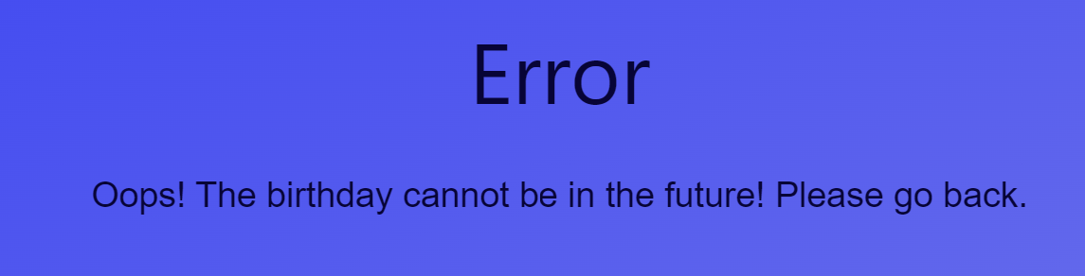

Figure 1: Error for a future birthday.

*Result*

The code is robust with respect to a user who tries to put a future birthday

* + 1. **Test Case 3: Wrong email**

*Goal*

To prove that the system will not allow to put an incorrect mail in the registration

*Input*

Email field: niccolo.veronese.it

*Expected output*

Impossible to create the account without a correct email field

*Actual output*

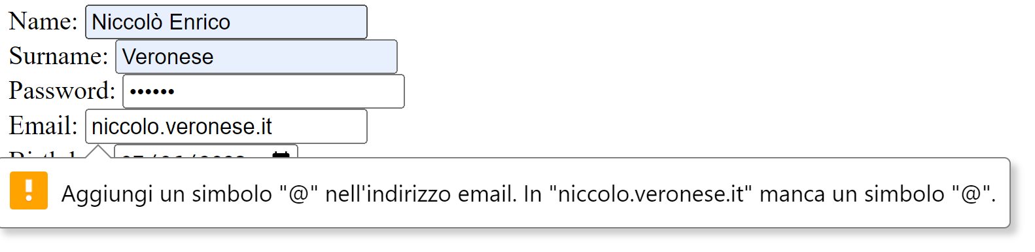

Figure 2: actual output in case of a wrong email

*Result*

The code shows good robustness with respect to wrong emails.

* + 1. **Test Case 4: Account with the same email address of another user**

*Goal*

To guarantee that two user do not have the same email address

*Input*

Email address: [gianluca99.giacomelli@gmail.com](mailto:gianluca99.giacomelli@gmail.com) (already existing)

*Expected output*

Validation error: "the given email is already registered"

*Actual output*

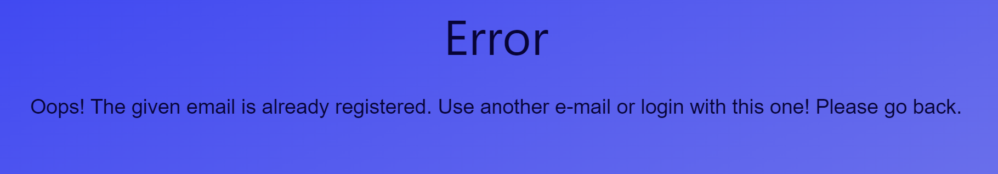

Figure 3: Error in case the user subscribes with al already registered email.

*Result*

The Iqueue prevents users to register with an already existing email.

Overall results (Account Registration)

The registration component is robust with respect to many wrong input parameters from the users such as a birthday date which is in the future, a wrong email address or even worse an email address which is already used.

Author

Niccolò Veronese

# Test set: **Shop registration**

Software tested

**Iqueue – Shop view**

Version

Latest

Goal

To show that the registration shop code is robust with respect to different inputs from the users and that it will allow to register a new shop in the Iqueue app.

* + 1. **Test Case 1: standard case**

*Goal*

To show that the shop registration code will allow to register a new shop.

*Input*

Opening time 08:00 and Closing time 18:00

*Expected output*

Registration successfully completed.

*Actual output*

Registration successfully completed.

*Result*

The code allows the user to register a new shop.

* + 1. **Test Case 2: opening time after the closing time**

*Goal*

To show that the shop registration code will not allow to insert an invalid opening time

*Input*

Opening time 09:00 and Closing time 08:00

*Expected output*

“The opening time must be before the closing time”

*Actual output*

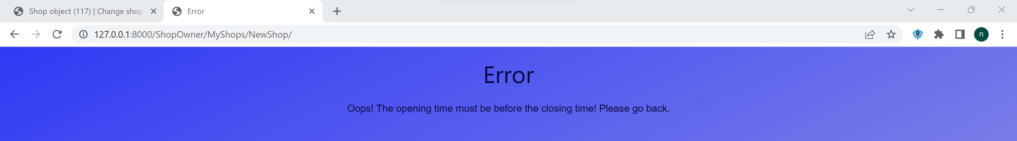

Figure 4: Error in case the Shop Owner inserts an opening time above the closing time.

*Result*

The code is robust with respect to a user who tries to put a wrong opening/closing time

* + 1. **Test Case 3: Negative max number of clients**

*Goal*

To prove that the system will not allow to put a negative max number of clients

*Input*

Max number = -2

*Expected output*

The code will not allow to enter a negative number.

*Actual output*

The code do not write the minus symbol and it doesn’t allow to go below zero with the arrow of the button

*Result*

The code shows good robustness with respect to negative number of clients.

* + 1. **Test Case 4: Negative slot durations**

*Goal*

To guarantee that the shop owner must not enter a negative slot duration

*Input*

Negative slot duration

*Expected output*

The code does not write negative numbers

*Actual output*

The code does not write negative numbers in that field

*Result*

The Iqueue prevents users to register the shops with a negative slot duration

Overall results (Shop registration)

The shop registration component is robust with respect to many wrong input parameters from the users such as a opening time which is after the closing time, negatives max numbers of clients and negatives time slots.

Author

Niccolò Veronese

# Test set: **Booking and QR reading**

Software tested

**Iqueue – Booking view, qr view**

Version

Latest

Goal

To show that the booking and the qr reading code is robust with respect to different inputs from the users.

* + 1. **Test Case 1: scan of a QR code**

*Goal*

To show that the Iqueue app is able to scan a QR code for a reservation

*Input*

Qr code

*Expected output*

Scan successfully completed and the reservation disappears.

*Actual output*

Scan successfully completed and if enters into the myReservations page

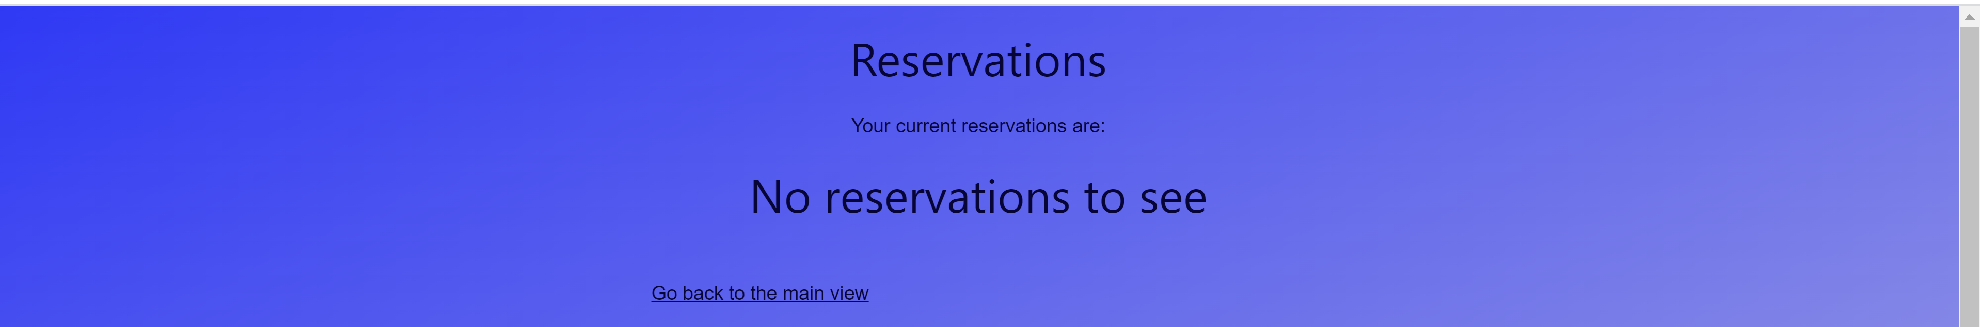

Figure 5: MyReservations view when the QR code has been scanned. It is supposed that only one reservations was created.

*Result*

The code allow the user to see its reservations and once the QR code has been scanned the reservation will disappear.

* + 1. **Test Case 2: scan of an already used qr code**

*Goal*

To show that the Iqueue app will not allow to scan two times the same qr code

*Input*

Qr code already used

*Expected output*

Impossible to scan the Qr code

*Actual output*

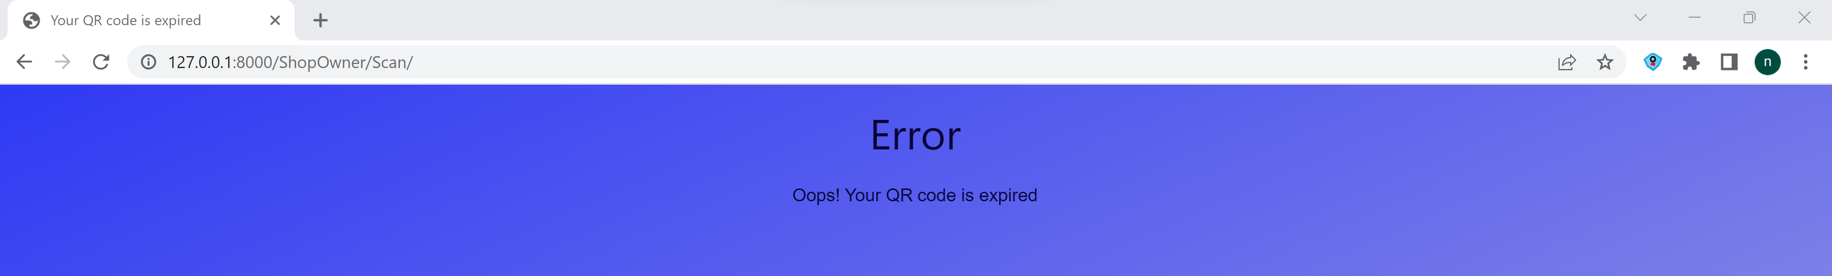

Figure 6: Error in case the Customer tries to scan twice the same QR code

*Result*

The code will not allow to scan two times the same Qr code.

* + 1. **Test Case 3: Selection of a time slot in the past**

*Goal*

To prove that the system will not allow to book a passed time slot

*Input*

Time slot in the past: 31/05/2023

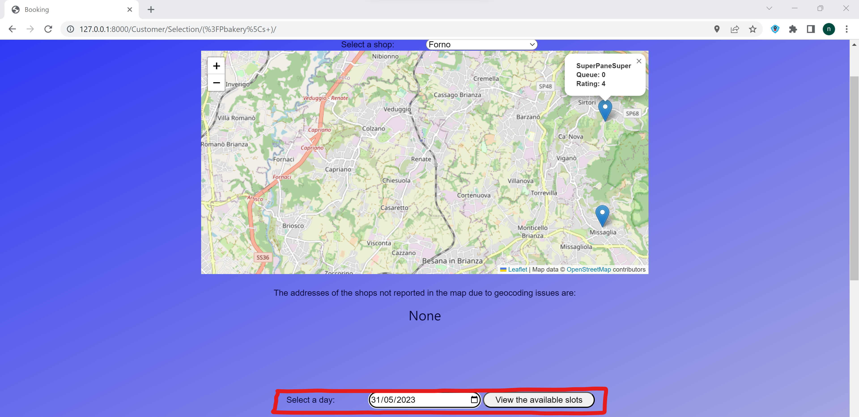

Figure 7: Input with past time slot.

*Expected output*

The code will not allow to book a time slot in the past.

*Actual output*

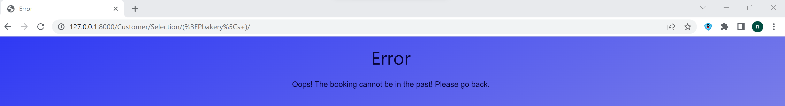

Figure 8: Error for a passed booking

*Result*

The code shows good robustness with respect to slots in the past since it shows that no slots are available for that date.

* + 1. **Test Case 4: Slots too far in the future**

*Goal*

To guarantee that the customer cannot book a slot more than one year in advance

*Input*

Booking for the 14/02/2025

*Expected output*

The code will not show the available slots

*Actual output*

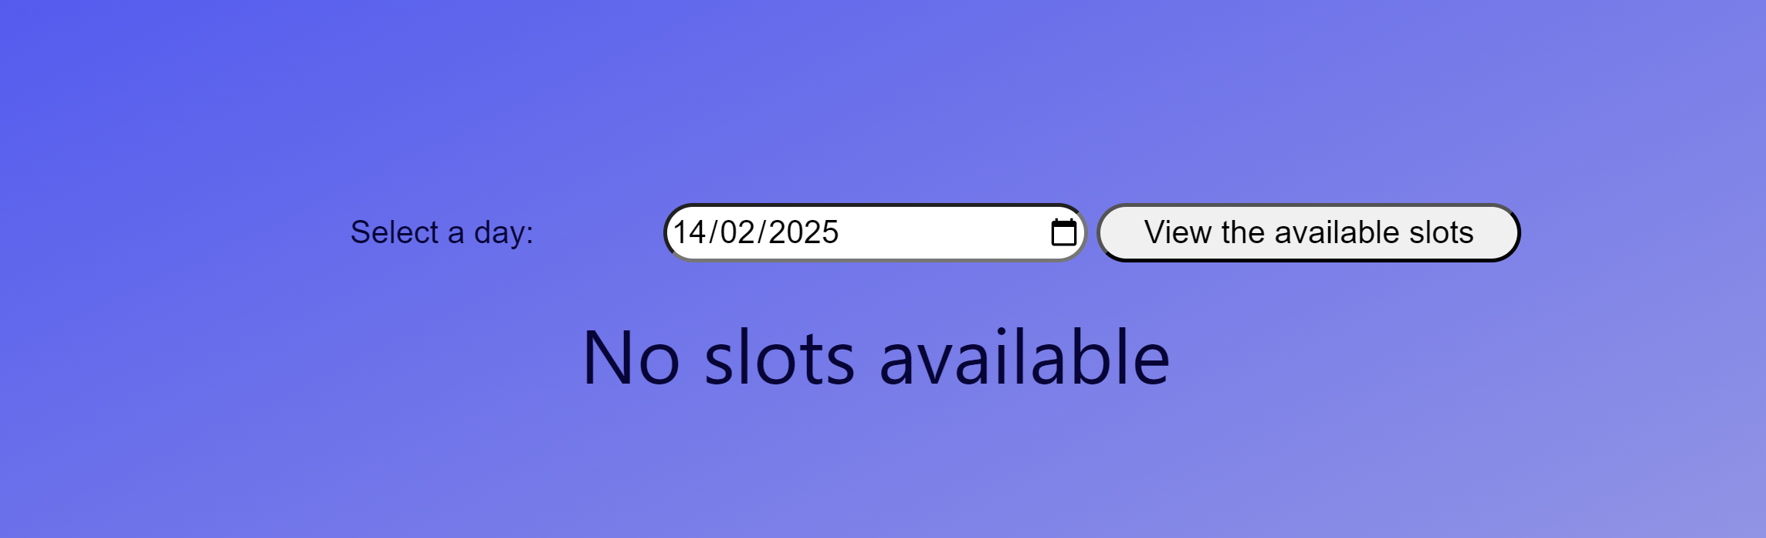

Figure 9: No available slots too far in the future (more than 52 weeks from the Shop creation)

*Result*

The Iqueue prevents users to book a slot that is more than one year in advance

Overall results (Booking and qr code reading)

The shop registration component is robust with respect to many wrong input parameters from the users such as a opening time which is after the closing time, negatives max numbers of clients and negatives time slots.

Author

Niccolò Veronese

# Test set: **Queue**

Software tested

**Iqueue – ShopQueueList**

Version

Latest

Goal

To show that the Iqueue app is able to correctly show the number of people in queue in front of a shop, considering also the ones without the Iqueue application.

* + 1. **Test Case 1: Booking for the 15th of June, no customer without Iqueue and actual date.**

*Goal*

To show that the Iqueue app can show to the Customer its position in the queue for the selected time slot.

*Input*

Booking for the 15th of June at the shop Niccolò Enrico Veronese and with no other customers in line on that day in that time slot.

*Expected output*

The position of the queue is 1.

*Actual output*

The position in the queue for the selected time slot is 1. Since this test case is developed on the 13th of June the queue in front of the Shop in that moment remains 0.

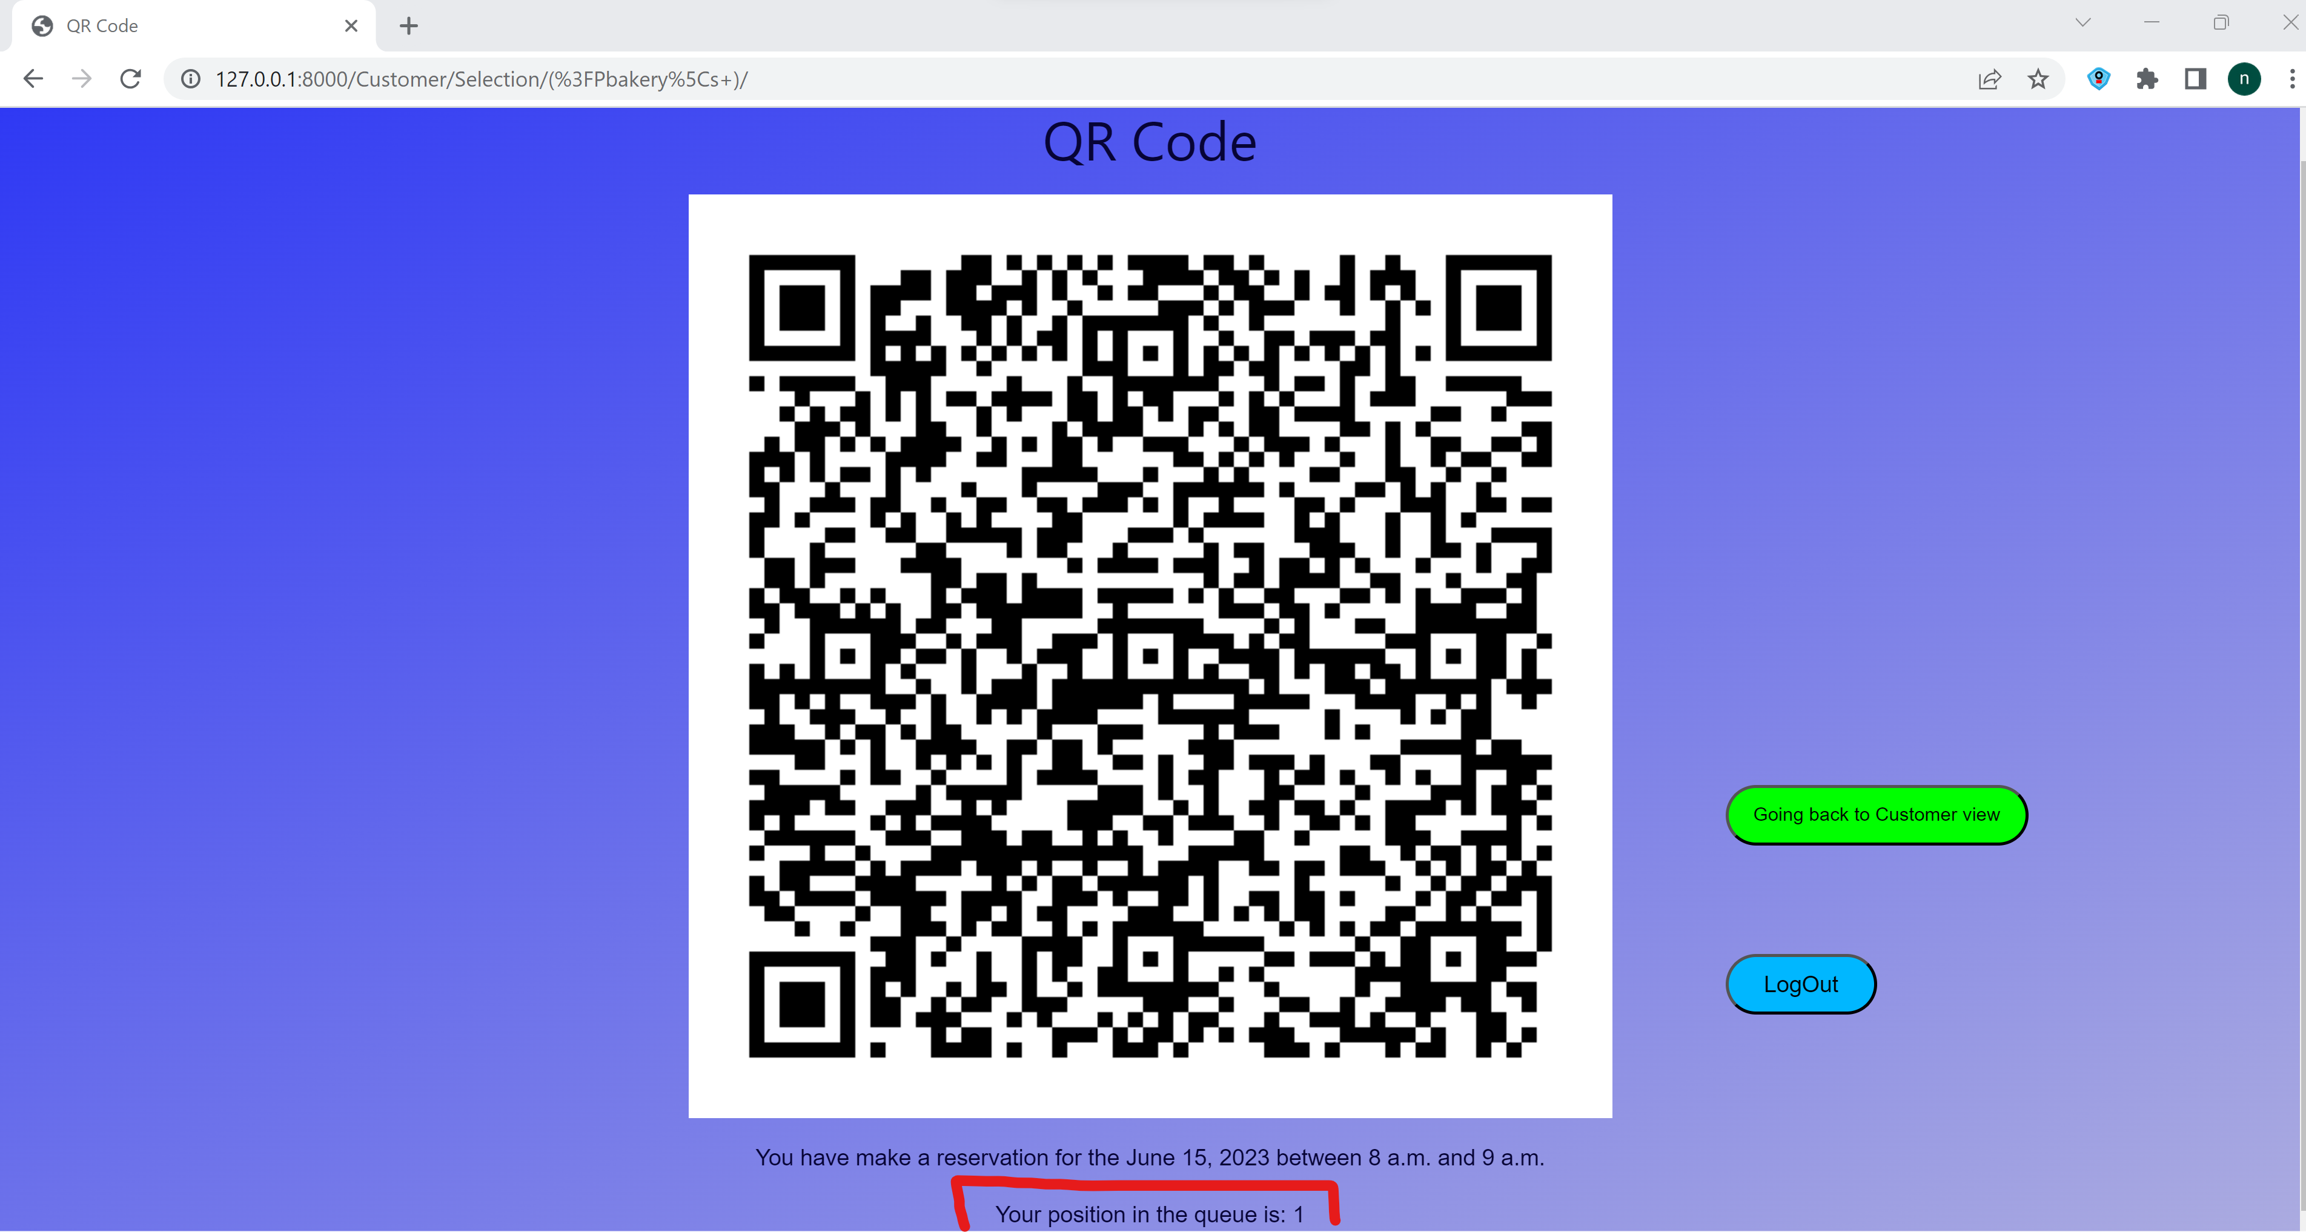

Figure 10: QR code with the position in the queue

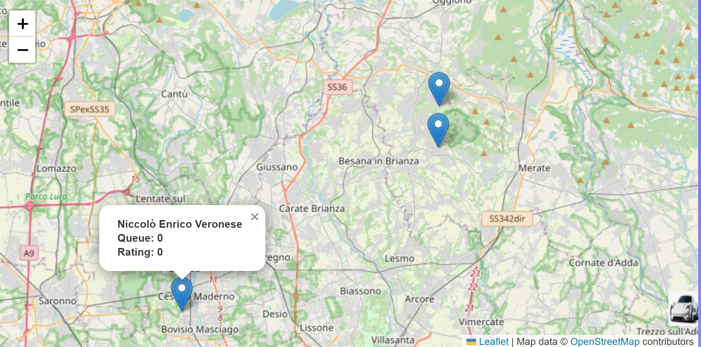

Figure 11: Map with the current queue in front of the Shop. Since the booking it is generated for a date different from the actual date it is correct that the queue remains 0

*Result*

The code allows the user to see its number in the queue for that time slot.

* + 1. **Test Case 2: Booking for the 15th of June, no customer without Iqueue and forced date**

*Goal*

To show that the Iqueue app can increment the number of people in queue in real time.

*Input*

Booking for the 15th of June at the shop Niccolò Enrico Veronese and with no other customers in line on that day in that time slot, the date now is forced to be the 15th of June.

*Expected output*

The queue in front of the shop will change to 1.

*Actual output*

The customer will see from the map that the shop has now 1 people in queue and the shop owner can see the same number of queue from its MyShops page.

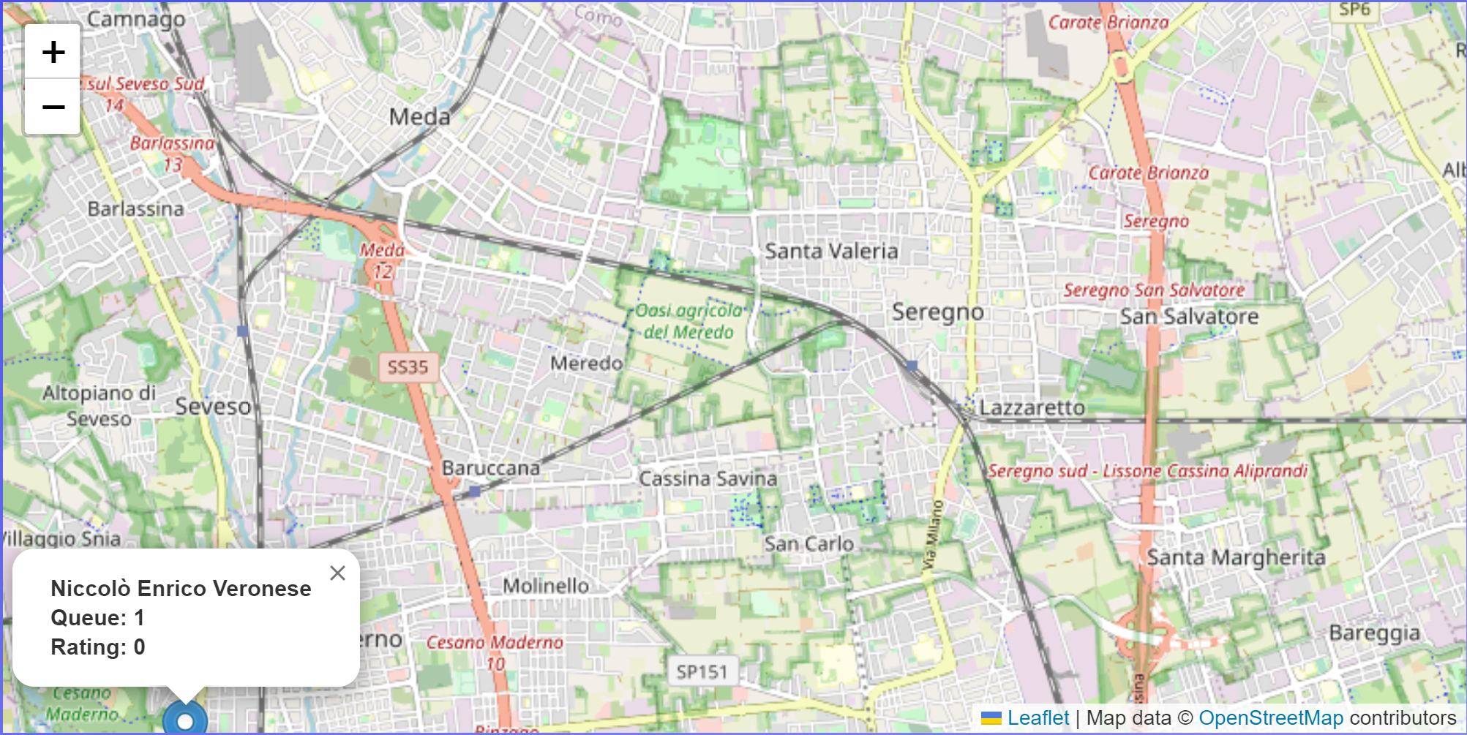

Figure 12: Updated queue in front of the shop in the map.

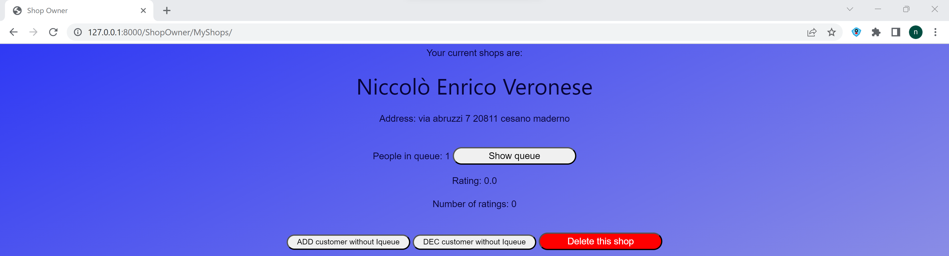

Figure 13: Updated queue in front of the shop in the MyShops view.

*Result*

The queue in front of the shop will change correctly in real time. In this case the real time has been simulated by forcing the date.

* + 1. **Test Case 3: Booking for the 15th of June, adding a customer without Iqueue and forced date**

*Goal*

To show that the Iqueue app can increment the number of people in queue in real time, considering also possible customers without the Iqueue app.

*Input*

Booking for the 15th of June at the shop Niccolò Enrico Veronese and with 1 other customer who enters in the shops without the Iqueue app.

*Expected output*

The queue in front of the shop will change to 2 both in the map and in the MyShop view.

*Actual output*

The customer will see from the map that the shop has now 2 people in queue and the shop owner can see the same number of queue from its MyShops page.

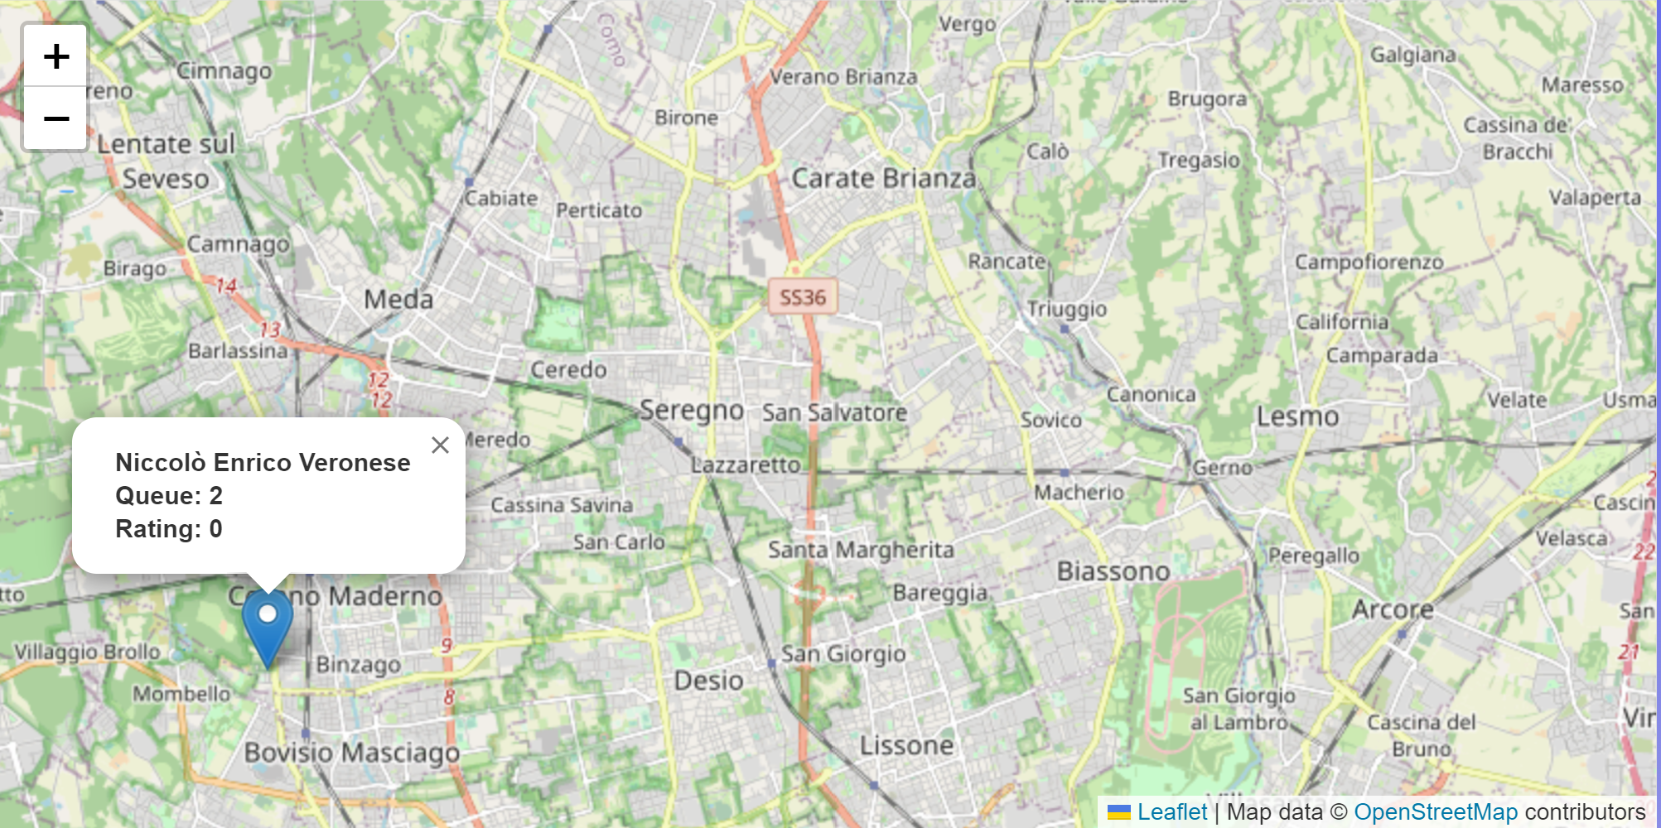

Figure 14: Updated queue in the map considering the customer without Iqueue app

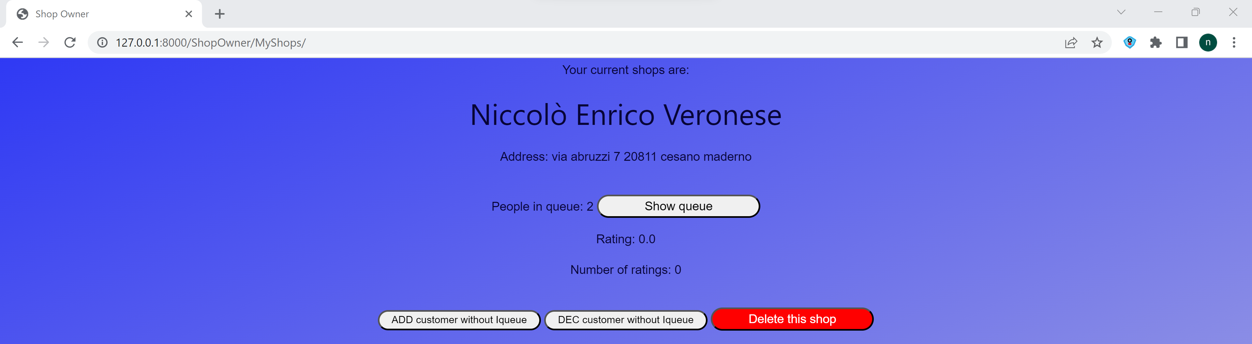

Figure 15: Updated queue in the My Shop view considering the customer without Iqueue app

*Result*

The software can correctly tracking the number of people in queue, also considering the ones without the Iqueue app.

* + 1. **Test Case 4: Scanning of the QR code and forced date**

*Goal*

To show that the Iqueue app can decrement the number of people in queue in real time, considering also possible customers without the Iqueue app.

*Input*

Scanning the QR code corresponding to the booking for the 15th of June at the shop Niccolò Enrico Veronese and with 1 other customer who enters in the shops without the Iqueue app.

*Expected output*

The queue in front of the shop will change to 1 both in the map and in the MyShop view for the Shop Owner.

*Actual output*

The customer will see from the map that the shop has now 1 people in queue (only the Customer without the Iqueue app) and the shop owner can see the same number of queue from its MyShops page.

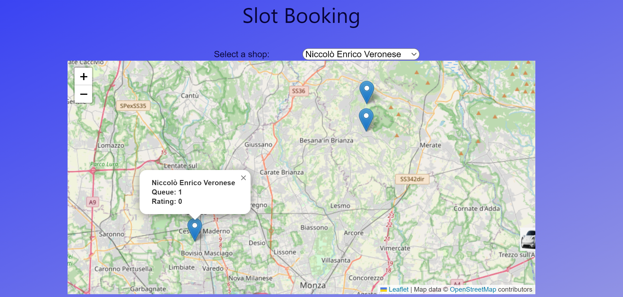

Figure 16: Update of the queue in the map when scanning the QR code

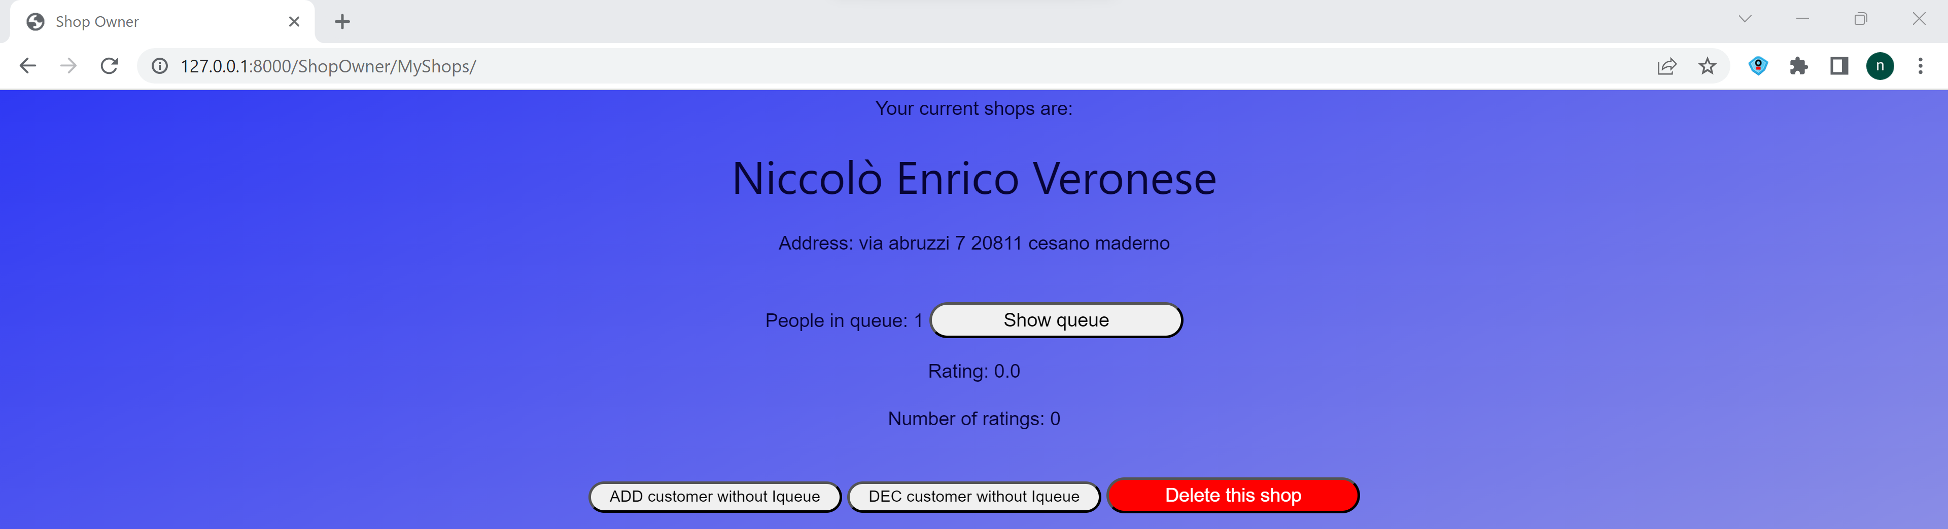

Figure 17: Update of the queue in the My Shop view when scanning the QR code

*Result*

The software can correctly track the number of people in queue when a QR code has been scanned, also considering the ones without the Iqueue app.

Overall results (Queue)

The queue component is able to correctly track the number of people in queue in front of the shop in real time and considering also the ones without the application.

Author

Niccolò Veronese

# Test set: **Product**

Software tested

**Iqueue – Product view, scan product, purchase list, wishlist**

Version

Latest

Goal

To show that the Iqueue app is able to register a product linked to a Shop, scan it using another QR code and define a purchase list and a wishlist with the products.

* + 1. **Test Case 1: Product registration**

*Goal*

To show that the Iqueue app can allow the Shop Owner to register a product for his shop.

*Input*

*Focaccia ligure - Price: 10.0 - Quantity: 5 –* Discount: 20%

Pizza margherita - Price: 5.0 - Quantity: 1 *–* Discount: 30%

*Expected output*

*Focaccia ligure - Price: 10.0 - Quantity: 5 –* Discount: 20%

Pizza margherita - Price: 5.0 - Quantity: 1 *–* Discount: 30%

*Actual output*

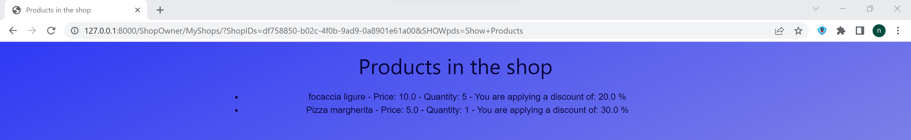

Figure 18: Products registered in the Shop.

*Result*

The code allows the user to correctly register the products for the Shop, without giving the possibility to insert negative values.

* + 1. **Test Case 2: Wishlist**

*Goal*

To show that the Iqueue app can allow the Customer to generate its Wishlist with the products of the Shops

*Input*

Search for “focaccia” and for “pizza”

*Expected output*

The software should show the products inserted before, since it is case insensitive, and give the possibility to add them to a wishlist.

*Actual output*

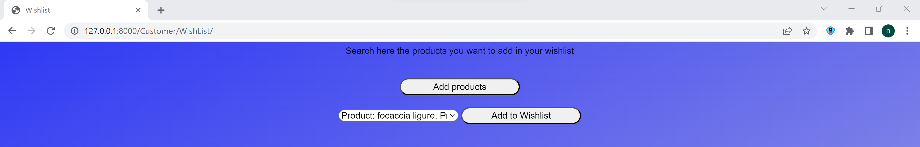

Figure 19: Product “focaccia ligure” found when searching for “focaccia”

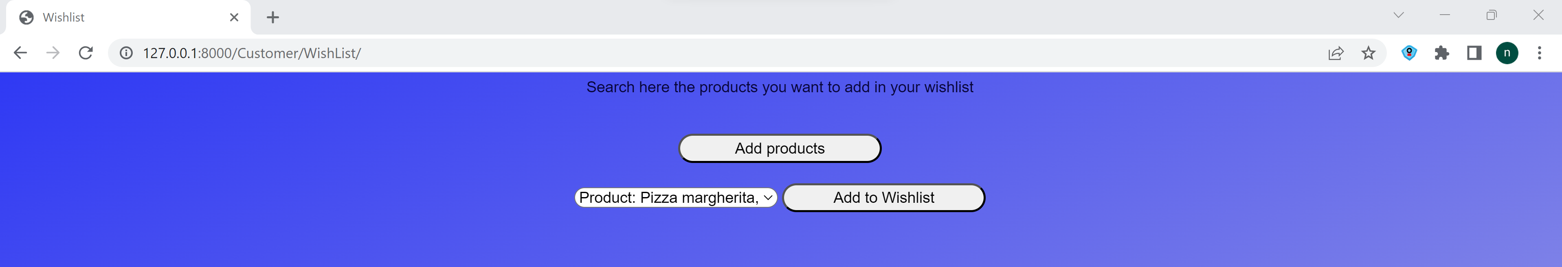

Figure 20: Product “Pizza margherita” found when searching for “pizza”

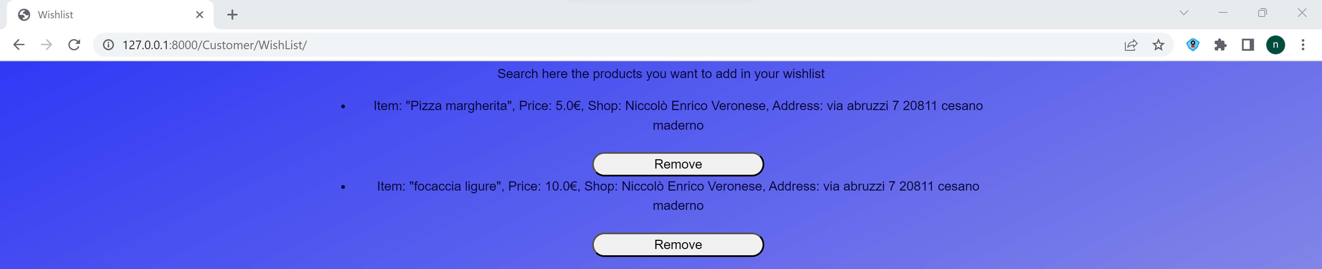

Figure 21: Wishlist of the Customer

*Result*

The code allows the user to correctly search the products, without problems with different cases, and to add them in a wishlist.

* + 1. **Test Case 3: Product scanning and purchase list**

*Goal*

To show that the Iqueue app can allow the Shop Owner to scan a product bought by the Customer and that the same product will be added to the purchase list of the Customer.

*Input*

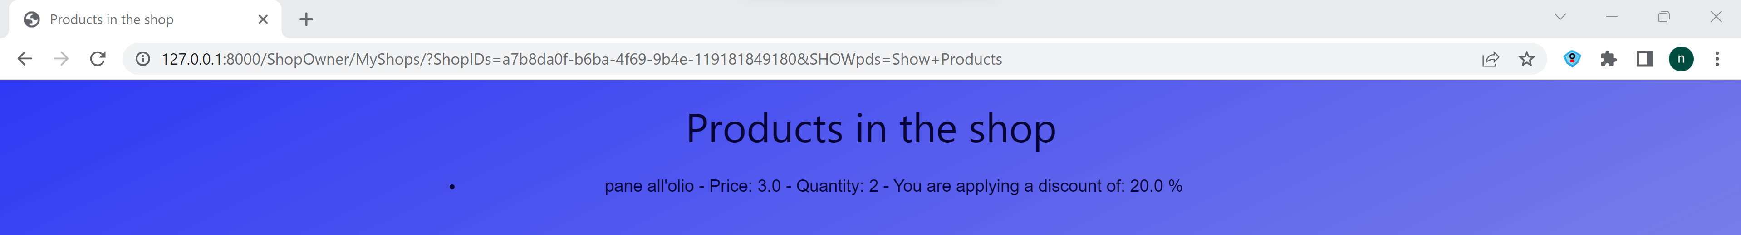

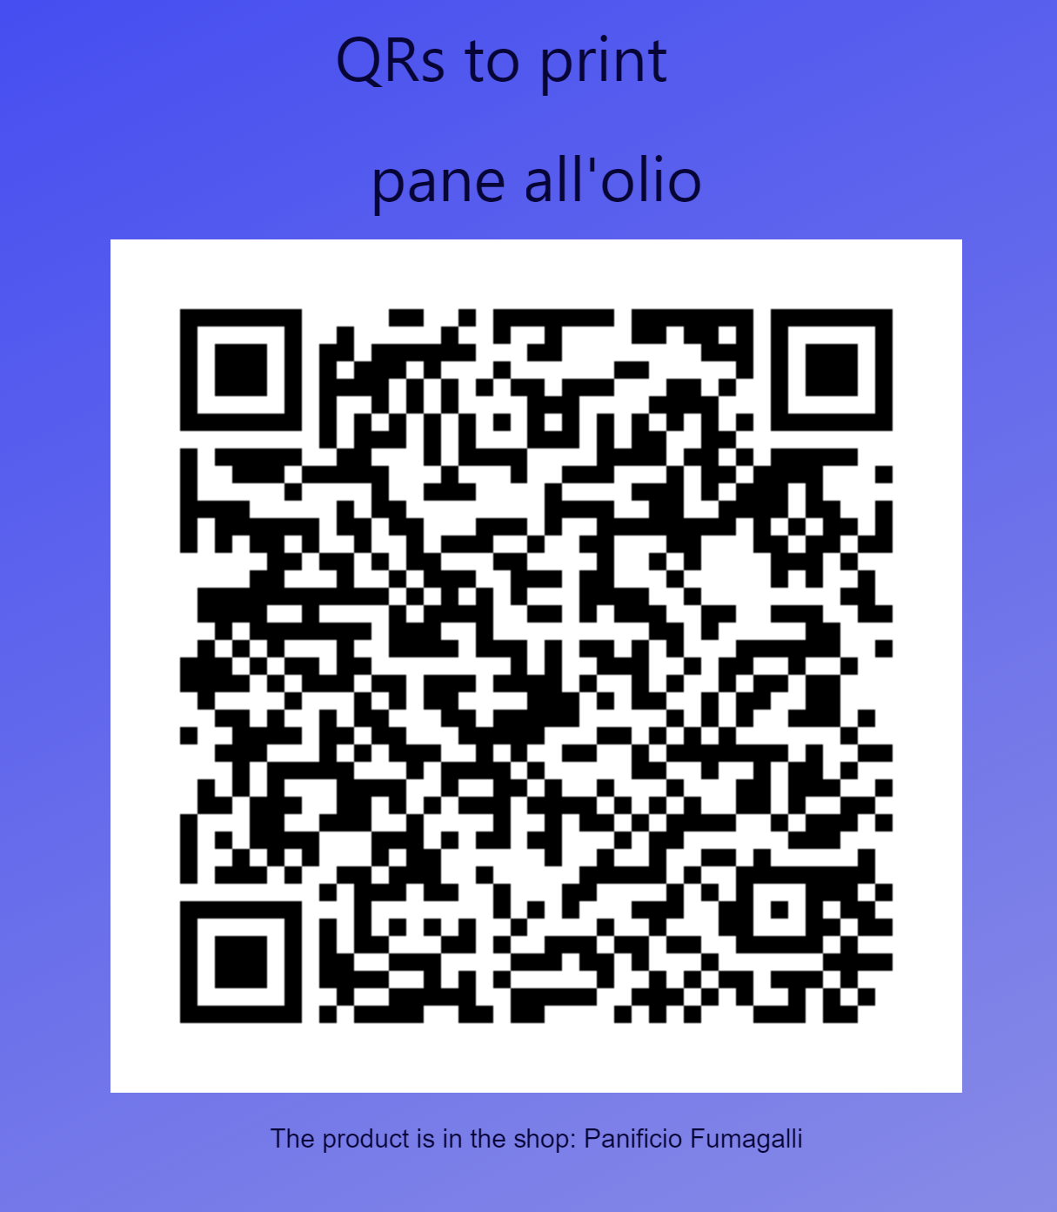

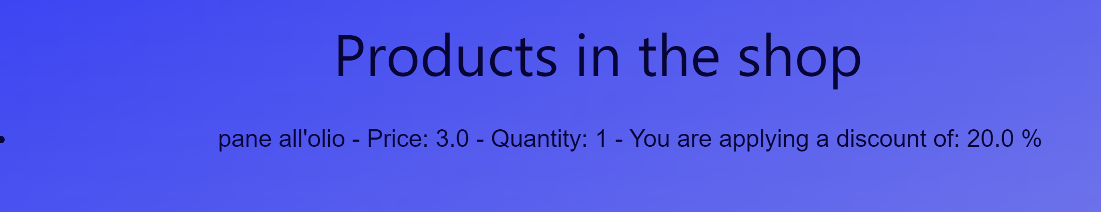

*Expected output*

*Focaccia ligure - Price: 10.0 - Quantity: 5 –* Discount: 20%

Pizza margherita - Price: 5.0 - Quantity: 1 *–* Discount: 30%

*Actual output*

*Result*

The code allows the user to correctly register the products for the Shop, without giving the possibility to insert negative values.

Overall results (Product)

The product component is able to correctly let the Shop Owner add products related to the Shops. In addition to that, the software guarantees that the Customer can add his products in a wishlist, without being sensible to case issues. Finally, it can track the number of sold products in real time and add also the results in the purchase list of the Customer.

Author

Niccolò Veronese

# Test set: **Advertisement**

Software tested

**Iqueue – Advertisement view**

Version

Latest

Goal

To show that the Iqueue app is able to register an advertisement for the Shop.

* + 1. **Test Case 1: Advertisement registration**

*Goal*

To show that the Iqueue app can allow the Shop Owner to generate an advertisement for his shop.

*Input*

Advertisement for the Shop “Panificio Fumagalli”

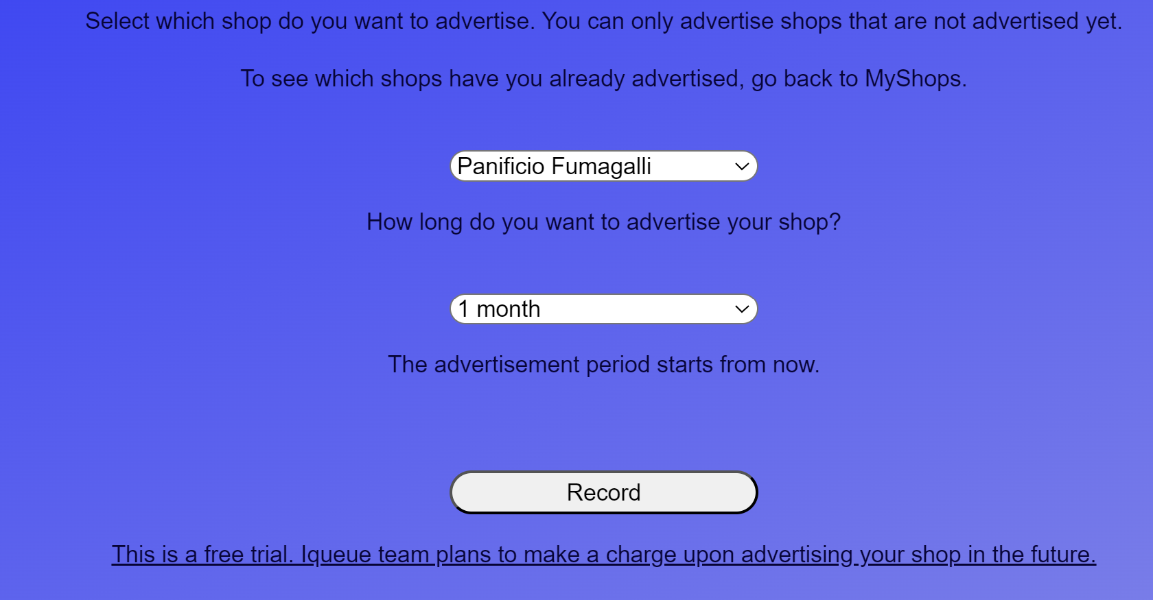

Figure 22: Advertisement for the Shop “Panificio Fumagalli”

*Expected output*

The Shop has been advertised and the image of the Shop appears in the initial page.

*Actual output*

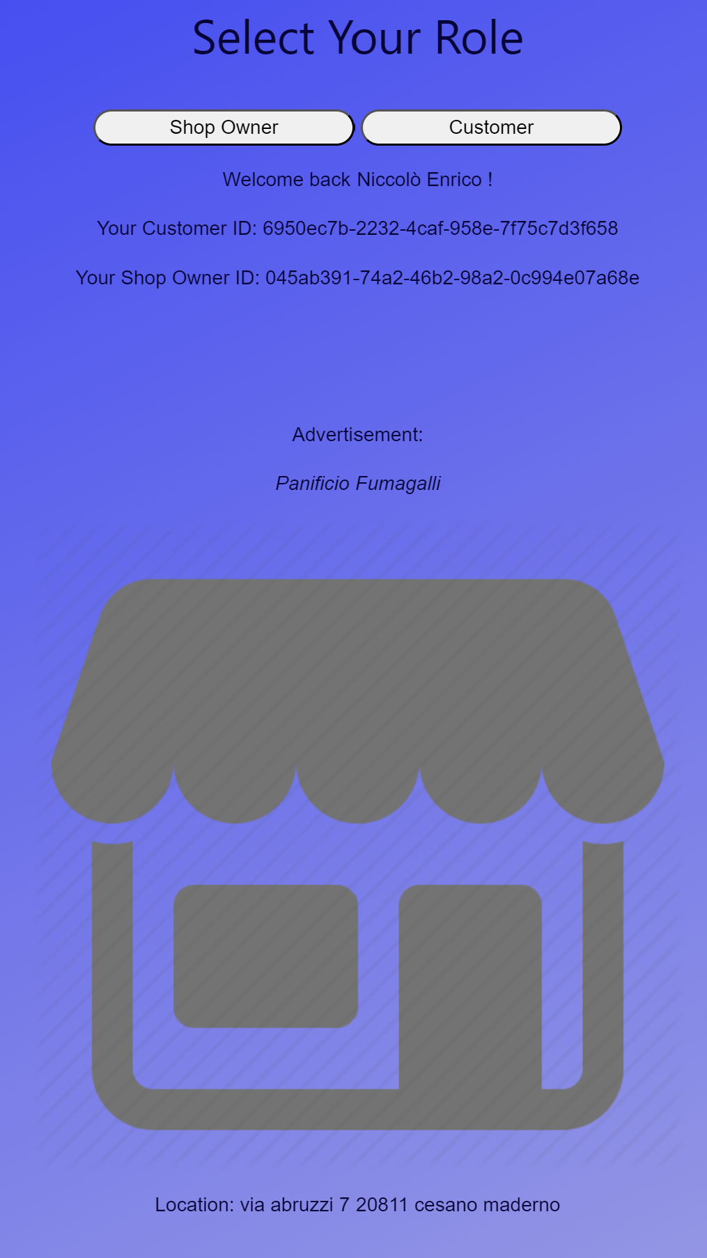

Figure 23: Advertised Shop in the homepage

*Result*

The code allows the user to correctly generate the advertisement for the Shop and the image with the shop name appears in the initial page of all the users.

Overall results (Product)

The advertisement component is able to generate an advertisement for the Shop and it shows the image with the promotion in the initial page.

Author

Niccolò Veronese

# Conclusions

The testing phase assures that the code of the Iqueue app meets the requirements and is robust with respect to the inputs of the users since all the main components of the system have been tested considering both ideal situation and strange/wrong inputs. The robustness of the system is a crucial aspect of the Iqueue application because it is characterized by many pages in which the user plays an active role. Although the results of the testing guarantee a high level of robustness, as for all the testing cases, these do not correspond to the absolute certainty of zero bugs inside the application. However, since both the white and black box cases have been developed, we can confidently say that the Iqueue application is robust and it is ready to be further developed.